https://myaccount.google.com/signinoptions/two-step-verification?rapt=AEjHL4OUo4baZES8rxZnOYRLqVKHpP_6qcNeXNhW2KJjg4mYIS2qJ52NLJNtMBLmTArRi3DAYZHXl8_8Ln-Vkm6-WD1WaMElbQ

Log in to your Gmail account and select "2-Step Verification." 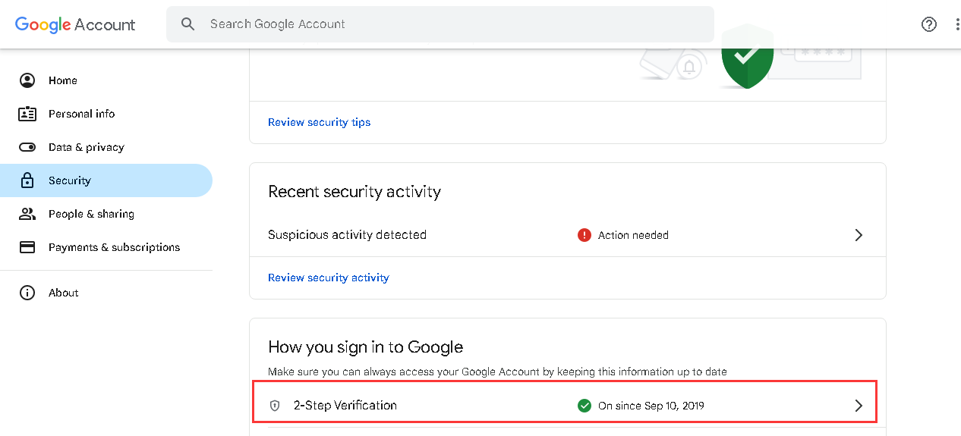
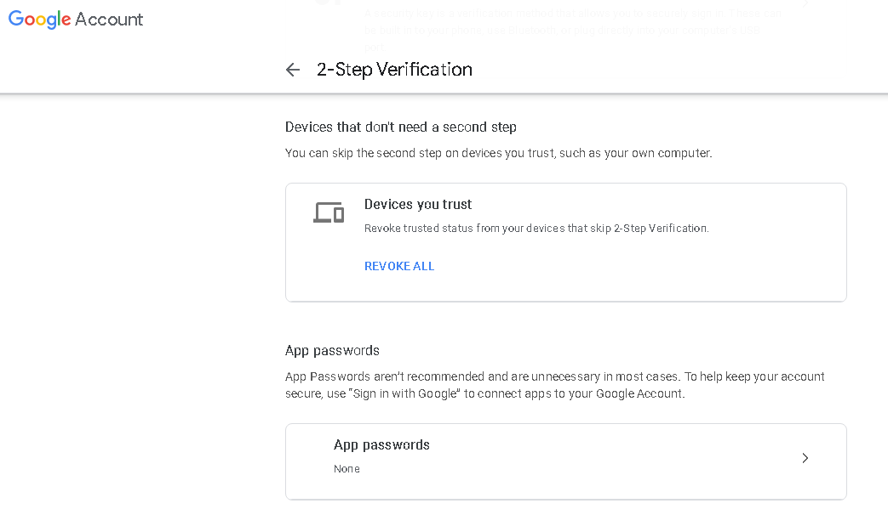

Set up an authorization code for third-party apps, and you can customize the name. 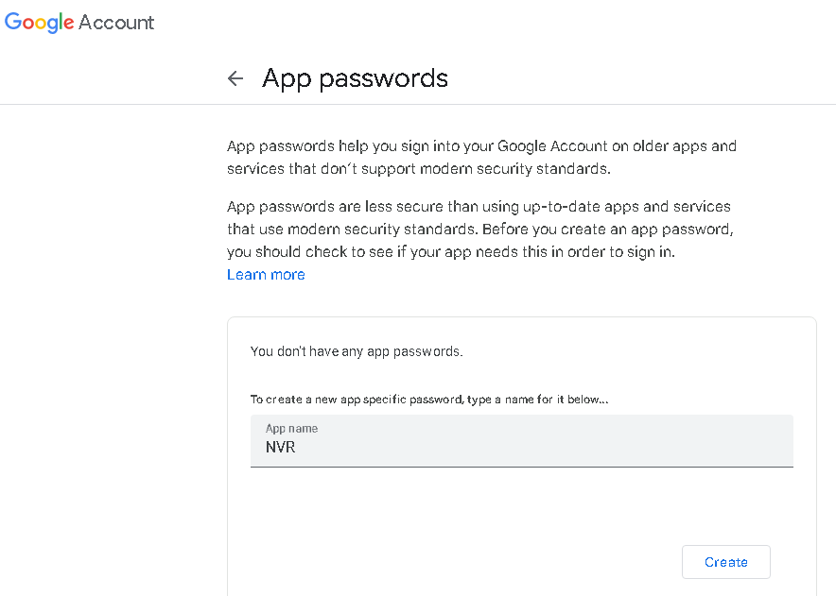
Click "Create," and the system will generate a 16-character password. This password will be used when logging in on a third-party app or device.

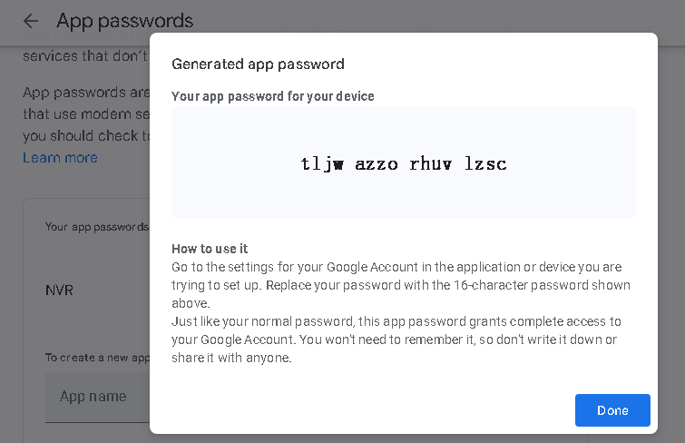
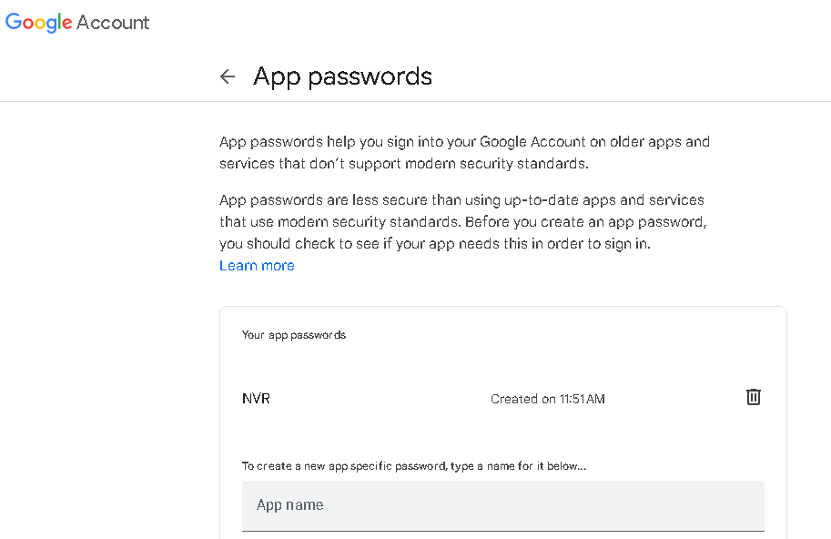
Go to Gmail Settings and make the following selections, then save.

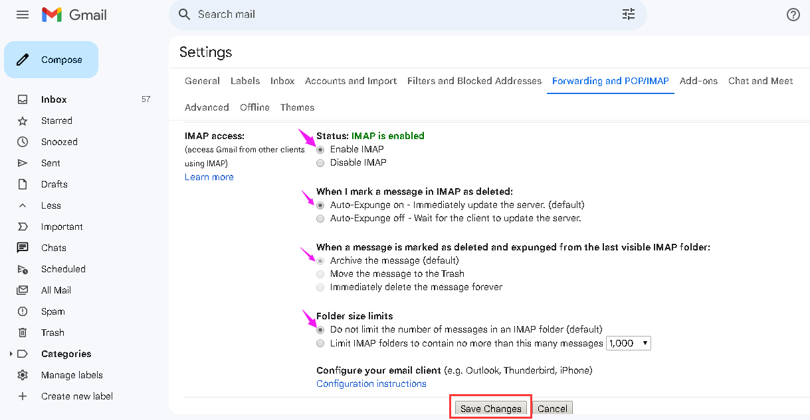

SMTP settings for apps or devices are as follows:
